GULISTAN & TURGUT OZAL EDUCATIONAL INSTITUTIONS
INFORMATICS LESSON PLAN

DATE :
DURATION : | 40 minutes
GRADE LEVEL: | 10th Class
SUBJECT : | Using Built-in Functions 2
OBJECTIVES : | To learn how to use predefined Excel functions

LESSON PLAN
Key words:
Materials used: | Microsoft Excel 2003 Book, Computer
Warm-up questions:

Introduction and explanation of the lesson;

2 AVERAGE FUNCTION

The Average function returns the average of selected cells containing numbers.
If your Excel worksheet contains the data shown in Figure 5.9, the following formulas give the results described in the table.

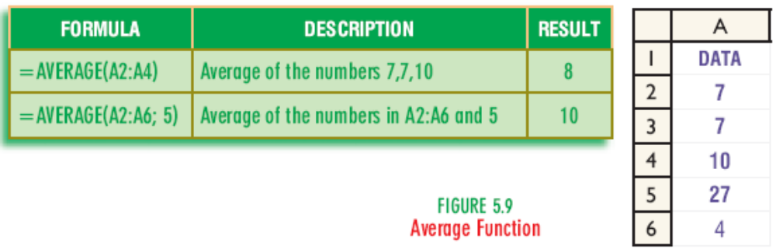

CONCLUSION:

HOMEWORK:

Teacher Director

